**Full Name: ____________________________**

**Class Exercise Challenge #5**

**GAME 2343/2347 and IMED 1345/2345**

After today’s lecture and hands on activities, you will need to complete the following challenge:

1. Create an array of high scores, and print out the average of the arrays.

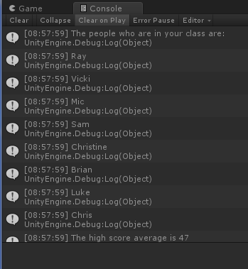

2. Toggle between the two states (checked and unchecked), you will need to take the screen shot, copy and paste it below.

3. Upload this document to eCampus before the due date.